Mad Mike Hughes has been a known flat earther for quite some time and rose to popularity among the space community when he launched himself in the air early 2018. From that experience, he had minor injuries but aspired to go higher. Although it was thought these launches were always to see the curvature of the earth, he later said before the most recent launch to 5,000 feet that he is simply a dare devil. He also supports Trump heavily and said he wanted to change his name to MAGA Mike Hughes. During the launch, the recovery system failed, and he died on impact. There were media present and caught the even clearly as they were recording his experience for a show to be aired later this year that follows amateur rocketeers and their adventures as they try to get closer and closer to the stars.'Mad Mike' Hughes, daredevil who built a homemade steam rocket, dies in launch attempt

By [Tariq Malik](https://www.space.com/author/tariq-malik) a day ago

He was 64.

[Comments (0)](https://www.space.com/daredevil-mad-mike-hughes-dies-in-homemade-rocket-launch.html#xenforo-comments-29619)

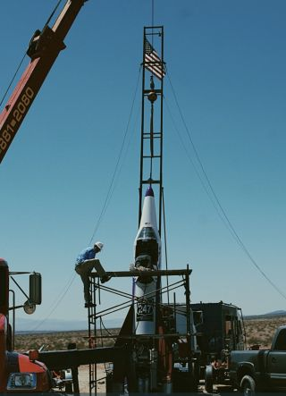

A view of "Mad Mike" Hughes' rocket, taken on Aug. 12, 2019.

(Image: © Darren Shuster/Pop Culture PR)

Daredevil "Mad Mike" Hughes died Saturday (Feb. 22) during his latest attempt to launch into the sky on a homemade rocket powered by steam.

Hughes, 64, [was attempting to launch 5,000 feet](https://www.space.com/mad-mike-steam-rocket-launch-homemade-astronauts-show.html) (1,524 meters) into the air from a location near Barstow, California, in a rocket he built with partner Waldo Stakes. The Science Channel, which was filming the launch attempt as part of the future documentary series "Homemade Astronauts," confirmed Hughes' death to Space.com.

"Our thoughts and prayers go out to his family during this difficult time," Science Channel representatives said in a statement. "It was always his dream to do this launch, and Science was there to chronicle his journey."

**Related:**[**'Mad' Mike's Steam Rocket Grounded by Craigslist Water Heater**](https://www.space.com/craigslist-water-heater-mad-rocket-launch.html)

[Click here for more Space.com videos...](https://videos.space.com/m/5Xo0MEop/mad-flat-earther-will-attempt-to-launch-himself-in-a-rocket-this-august?list=9wzCTV4g)

Volume 90%

01:15

01:26

01:55

[According to CNN](https://www.cnn.com/2020/02/22/us/science-channel-mike-hughes-dead/index.html), the San Bernadino County Sheriff's office responded to the fatal rocket crash off Highway 247 in Barstow. [NBC News reported](https://www.nbcnews.com/news/us-news/daredevil-mad-mike-hughes-dies-homemade-rocket-launch-filmed-tv-n1141286) that the launch lifted off from private property in the Barstow area.

The Sheriff's Office did not identify Hughes in a statement, saying only that authorities had pronounced a man dead at the scene of the rocket crash, CNN added. The Science Channel later confirmed Hughes' death.

Hughes has repeatedly tried to launch homemade rockets and [actually did launch an earlier rocket in 2018](https://www.space.com/40083-flat-earther-mike-hughes-launches-homemade-rocket.html). During that flight, which reached a maximum height of 1,875 feet (572 m), Hughes suffered compressed vertebrae but still aimed to launch ever higher.

Attempts to launch this current steam rocket in August 2019 [were prevented by a faulty water heater](https://www.space.com/craigslist-water-heater-mad-rocket-launch.html).

In the past, Hughes said he believed the Earth was flat, with some publications stating his launches were aimed at seeing the Earth's curvature for himself. In August 2019, however, Hughes told Space.com that his flat-Earth belief was not his launch motivator. He was simply a daredevil, pushing the envelope of homemade rockets, Hughes said.

Hughes and Stakes made up one of three different teams working to build and launch their own rockets while being filmed for the Science Channel's "Homemade Astronauts" series. The teams were shooting to get as close as possible to the Karman line, a boundary about 62 miles (100 kilometers) above Earth.

The Science Channel series is being produced by World of Wonder. It is currently in production and will premiere some time in 2020.